CURRICULUM VITAE
ROHITASH KUMAR
Vill:Khaprail Chhaparra Post:samodiya Teh:Swar Distt: Rampur (U.P.) 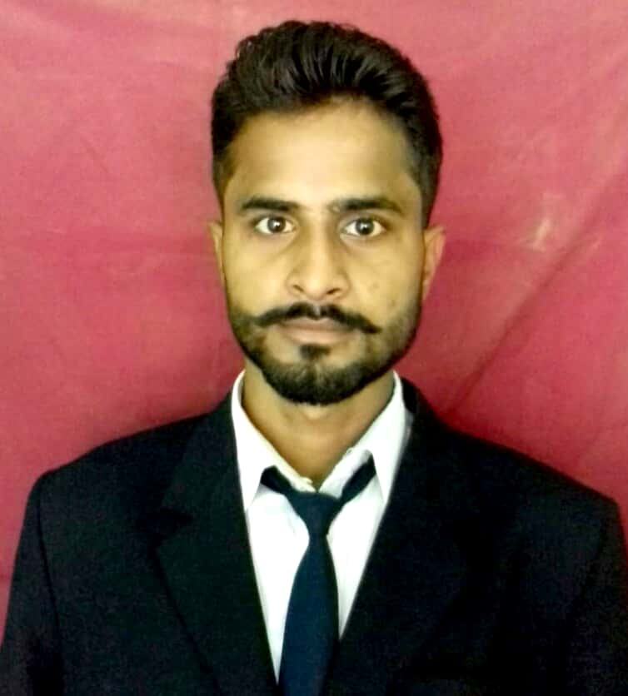
Contact no: 9690179518
7351058720
mauryarohitash95@gmail.com
08-12-1997

objective
I would like to be a part of an organization where I could use and enhance my knowledge and talent for the development of both the organization and myself.

key skills
- Active listener
- Confident
- Quick learner
ACADEMIC QUALIFICATION
Qualification | Aggregate | Pass out Year | Institute/School, City | University / Board
B.tech(CE) | 83.35% | 2019 | Moradabad Institute Of Technology,Moradabad | AKTU
Intermediate | 88.40% | 2015 | Subhash Smarak I. C. Khandikhera Rampur | State Board
Class X | 83.50% | 2013 | DR. SPMSVM H S S  Rustamnager Chhaparra swar Rampur (U.P) | State Board

TECHNICAL SKILLS
 Auto cad
• MS- Office (Excel, Word & Power Point
CERTIFICATION
▪ Auto Cad Certification

▪ CCC Certification
INTERNSHIP
- Company: Sadbhav Engineering Limited
Duration: 40 days
Project on: Rampur-Kathgodam NH-87 Pkg-1

Hobbies
- Reading, Teaching
- Dancing & Reaseach

personal details
Name : Rohitash kumar, Father’s Name : Khem karan
Language : English, Hindi , Gender : Male Marital Status : Unmarried. DECLARATION: - The above details complete my curriculum vitae while I submit for your kind perusal awaiting an early & favorable response.
DATE: -
PLACE: - (ROHITASH KUMAR)

