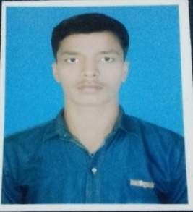 **RESUME**

**ALOK KUMAR JHA**

**Contact No:+91-9205532435**

**Email Id**: [alokjha.aj1@gmail.com](mailto:alokjha.aj1@gmail.com)

**PERSONAL DETAILS**

* **FATHER’S NAME**: Rajeev Kumar Jha
* **DATE OF BIRTH**: 16/02/1998
* **PERMANENT ADDRESS**: Vill.- Nawada,P.O.-Bahera Dist.-Darbhanga, Pin.-847201 (Bihar).
* **PRESENT ADDRESS**: Plot 101 Khedi Enclave Opp. Little Angel School Fridabad Haryana 121004.
* **LANGUAGE KNOWN**: Hindi, English, Bhojpuri and Maithali.
* **MARTIAL STATUS**: Unmarried.
* **NATIONALITY**: Indian.

**GENERAL QUALIFICATION**

|  |  |  |  |  |
| --- | --- | --- | --- | --- |
| **YEAR** | **LEVEL** | **UNIVERSITY/BORD** | **MARKS OBTAINED** | **PERCENTAGE** |
| 2014 | 10th | Bihar Board | 259 | 51.8% |
| 2014 1st-sem | Diploma | W.B.S.C.T.E. | 6.8 GPA | 61.3% |
| 2015 2nd-sem | Diploma | W.B.S.C.T.E. | 7.5 GPA | 71.2% |
| 2015 3rd-sem | Diploma | W.B.S.C.T.E. | 6.4 GPA | 61.3% |
| 2016 4th-sem | Diploma | W.B.S.C.T.E. | 6.8 GPA | 64.5% |
| 2016 5th-sem | Diploma | W.B.S.C.T.E. | 7.2 GPA | 68.2% |
| 2017 6th-sem | Diploma | W.B.S.C.T.E. | 7.1 GPA | 66.6% |

**CAREER OBJECTS**

* To work in a challenging and dynamic environment, to keep adding values to myself and simultaneously contribute to the growth and success of the Organization.

**HOBBIES**

* Virtual cricket playing and Reading books.

**DECLEARATION**

* I hear by certify that the information furnished above is correct and complete to the best of my knowledge and belief and I bear the responsibility for the correctness of the above mentioned particulars.

**Signature DATE:**

Alok Kumar Jha