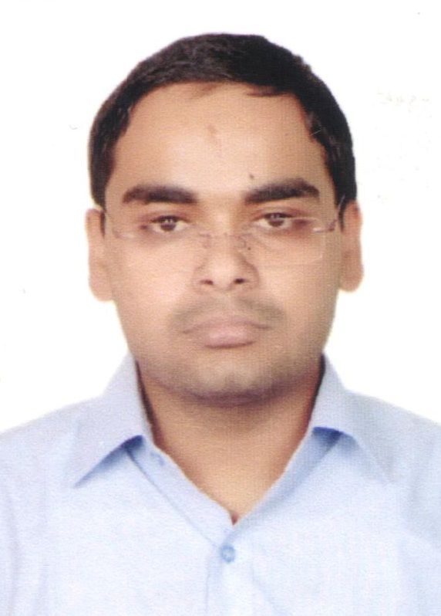
Curriculum Vitae

Mohit Chaudhary
HNo 62a Madangir Village
New-Delhi 110062
Mobile : +917011883015
Email : ch.mohit91@yahoo.com

Objective:
- A Certified Mechanical professional with 4+ years of professional experience as a Quality Engineer in Compression Moulding and High Pressure Die Casting seeking challenging opportunity to work for a renowned organization to enhance my knowledge, skills and techniques which can benefit the Organization.

Professional Experience:
- Company Name: | ASK FRASLE FRICTION PVT. LTD, MANESAR (HARYANA)
The Company Profile: | Ask Frasle Friction Pvt. Ltd is a leading automobile spare parts manufacturing company which deals in heavy duty disk brake pads and Brake Linings for heavy vehicles.
Duration: | 1st February 2018 - Current
Role: | Quality Engineer (Brake Lining Moulding)
Duties Performed: | - Improving Quality process and implementing Various techniques of Kaizen Leading process optimization, root cause analysis and driving scientific and engineering principles into a rapidly changing industrial manufacturing facility  - Implementing product quality improvements by completing root cause analysis leveraging scientific and engineering principles  - Creating, refining, educating, and implementing standard work and process adherence throughout the workforce  - Investigating improvement opportunities and initiating critical manufacturing process improvement projects  - Planning and conducting factory tests to follow through on any of the preceding activities  - Working with production operators, production leaders and other technical support staff in hands-on troubleshooting of technical problems  - Creating and maintaining data collection systems  - New Parts and Sample Development  - Seven QC Tools for finding root cause of the problems  - Implementation of 5S  - Internal Audit of the Process as per Control Plan  - Making necessary changes to make process flow easier and convenient
- Company Name: | ASK AUTOMOTIVE PVT. LTD, MANESAR (HARYANA)
The Company Profile: | ASK AUTOMOTIVE PVT. LTD is a leading automobile spare parts manufacturing company which deals in brake shoes, clutch shoes, clutch plates, disk brake pads and control cables for all two wheelers, three wheelers and four wheels vehicles.  ASK AUTOMOTIVE PVT. LTD also deals in heavy duty disk brake pads for heavy vehicles
Duration: | 5th December 2016 – 31st January 2018
Role: | Quality Engineer (Brake Shoe and Clutch Plate)
Duties Performed: | - Develops working knowledge of all process areas including process flow, operator responsibility, major quality attributes and areas for improvement  - Help oversee and develop manufacturing standards, including machine capacity, quality control, tools and equipment, pathways and cycle times  - Conducts and documents results of process trials to improve productivity and/or quality  - Leads quality focused improvement efforts and projects  - Develop and implement the process quality control management systems in operation, including procedures and WI for inspection
- Company Name: | PROCAST INDIA, FARIDABAD (HARYANA)
The Company Profile: | PROCAST INDIA is an Aluminum casting company which deals in machined and non-machined Aluminum products.  PROCAST INDIA also deals in shot blast products, Die making and EDM products.
Duration: | 1st October 2014 – 30th November 2016
Role: | Quality Engineer (High Pressure Die Casting)
Duties Performed: | - Handling high tonnage machines of 120, 200 Tons  - In process inspection of all products  - Setup Approval Report of Machines  - Performing internal Audit of the PDC department on daily basis  - Auditing of quality, environmental & safety systems  - In- house process audit & new product development. Exposure to 5s, Kaizen & TPM Techniques  - Setting process parameters for new trial Dies for Production  - Performing Process audits.  - Making continuous improvement at working area and implementing kaizen  - Rejection control of casting Defects

Educational Qualification:
Graduation:  B. Tech (Mechanical) | S.G.T INSTITUTE OF ENGINEERING AND TECHNOLOGY (HARYANA) with 78.4% (2014)  under Maharishi Dayanand University, Rohtak (Haryana)
Senior Secondary Examination: | Delhi Police Public School (New-Delhi)  C.B.S.E with 79% (2010)
Matriculation: | DAV Model School ,Yusuf Sarai, Green Park (New Delhi)  C.B.S.E with 83.4% (2008)

Strength:
- Lean Quality Tools (FMEA, Pareto Charts, Fishbone Diagrams)
- Statistical Process Controls (SPC)
- Quality Auditing
- Quality Documenting.
- Good learning Skills.
- Scrap Reduction & Output Increase
- Process Development & Improvement
- Hard working, sincere, polite & punctual.
- Able to act on my own initiative and as well as to work as part of a team.
- Problem Solving

Computer Proficiency:
Tools: | - MS Office  - AutoCAD, Solid works  - Minitab 18
Operating System: | All OS
Web: | Good hold in surfing net.

Academic Training:
Company Name: | JAI BHARAT MARUTI LTD, Gurgaon (Haryana)
The Company Profile: | - JAI BHARAT MARUTI LTD. setup in 1987, is the largest joint venture of MARUTI UDHYOG LIMITED, in collaboration with SUZUKI MOTOR CORPORATION of JAPAN  - The JBM Group deals in broad range of sheet metal assemblies, die casting components and forging for domestic and export market.
Duration: | 10 Months
Role: | Trainee in Quality Department

Academic Projects Undertaken
- PDI defects analysis and reduction (6 months) | - This project is based on determination of various kinds of defects during Predispatch Inspection using various tools and parameters of inspection. After analysis of the defects various procedures are taken to improve the quality of the component.  The defects are reduced by various Poke-Yoke techniques and general awareness among the workers.
- Defects analysis of ISGEC-3 line (2 months) | - This project is based on analysis of various defects that occur during production process in the ISGEC-3 line such as Dent, Cracks, Wrinkles, etc and determination of main causes of defects such as Miss-feed, mismatching parameters, etc.
- Breakdown at ISGEC-3 line (2 months) | - This project is based on analysis of various problems that results in the breakdown of the ISGEC-3 Line such as Oil Leakage from the ends, overheating, worn-out parts, etc.

EXTRA CO-CURRICULAR ACTIVITIES:
- 2nd prize in “Bharat ko Jano” in Delhi State (2004&2005)
- 1st prize in “Bharat ko Jano” in Delhi State(2006)
- Participated in National Cyber Olympiad (2009)

Hobbies & Interests:
- Watching Cricket.
- Surfing Net.
- Playing Cricket.

PERSONAL INFORMATION

Personal Information:
Name: | Mohit Chaudhary
Father’s Name | Mr. Yogesh Chaudhary
Date of Birth: | 08th September 1991.
Address: | Hno 62a Madangir Village, New-Delhi 110062
Gender: | Male
Current CTC: | 21000/- PM
Expected CTC: | 25000/-PM
Languages: | English, Hindi
Geographical Preference: | Delhi-Ncr, Haryana
Reference: | Mr. Arun Kumar (HOD)  Mr. Pradeep Chauhan (Quality Department JBML)  Mr. Raman Singh (Procast India)  Mr. Naveen Saini (Ask Frasle Friction Pvt. Ltd)

Declaration:

I hereby declare that the above information is true and correct to the best of my knowledge.

Place: New Delhi

Date: (Mohit Chaudhary)

