**Which is the Best Cooktops for Your Smart Kitchen?**

There are so many cooktops and brands in the market like glass top gas stoves, digital gas stoves, automatic auto ignition gas stove, heavy brass burners stoves etc. So many options are create confusion in our mind. Then we confused to buy best cooktops for our kitchen. Here are tips to find right cooktops for your smart kitchen. For more read [(click here)](http://www.goodflames.com/blog/upgrade-your-kitchen-with-the-right-cooktops/)

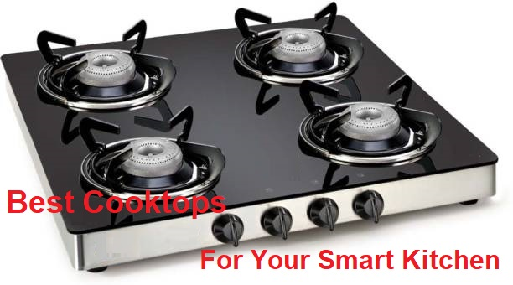

[**http://www.goodflames.com/blog/upgrade-your-kitchen-with-the-right-cooktops/**](http://www.goodflames.com/blog/upgrade-your-kitchen-with-the-right-cooktops/)

[goo.gl/EvQgTw](https://t.co/tmR0mSUkIT)

**Best Gas Stoves in India**

**Glass Top Gas Stoves**

**Auto Ignition Gas Stove**

**Upgrade your Kitchen with the Right Cooktops**

Kitchen is one of the most essential part of your home. It is from where you get energy to drive your life. Undoubtedly, one should rejoice cooking to make scrumptious meals. To rejoice, it is important to make it stylish with proper appliances. Kitchen can be considered heart of your home, where you and your family gather to create meals and happiness.

There are numerous things to upgrade in kitchen like dishwasher, integrated microwave/oven, coffee machine, etc. But, the most essential is cooktop without which kitchen is incomplete. Thus, it is essential to buy the one that fits your needs and look of the kitchen. Choose a design that complements the look of your kitchen and your lifestyle.

**Does your kitchen need transformation?**

If you are bored with the layout and design of your kitchen, it’s time to transform it by redesigning and buying stylish appliances. The key consideration in transforming or building a new kitchen is the proper layout, location and size of the kitchen. Choose appliances like Cooktops, oven, refrigerator, microwave, etc. based on the size and look of the kitchen. With a proper planning you can renovate kitchen within your budget. Cooktop is one of the most important part of your kitchen. Select it wisely that can make your cooking easy and fast, giving modish look to the kitchen.

**Choosing a right Cooktop**

There are wide variety of cooktops based on features and range in the market that you can choose from. While upgrading it is advised to buy a cooktop with latest features and durability so that it can last longer. Based on your lifestyle, firstly choose between Gas cooktop, electric or induction. If you opt for a Gas cooktop, there are wide range of options having elegant look. These days, glass top gas stoves are the latest to opt from. Give Glass top given smart look to the kitchen and is easy to clean. The next thing to decide upon is type of burner. If you have a moderate size of family and wants to cook faster, a 3 burner or 4 burner Gas stove would be suitable for you. Cooking is an everyday job and with the inclusion of appropriate appliance you can make huge difference in your life.

Other features to look for buying Gas chulha or gas stove include auto ignition by which you can light your gas stove without lighter or matchstick. Also, it is advisable to buy cooktop having brass burners as they are more durable. Cooking is one kind of thing that even if one doesn’t like it can’t be ignored. So make it more interesting and enjoyable with a right gas top. There are many brands which offer Glass top gas stoves assuring it to be best gas stove in India. But, we would recommend you to select gas stove that matches your preferences and budget.

It is also important to decide a right location for your gas stove in the kitchen – whether it’s a fitted gas burner or a free standing unit. As there are pros and cons of both hobtop (fitted gas unit) and gas top (free standing unit), the choice totally depends on your like. Free standing unit would be easier to clean and replace while hobtop would give cleaner look to the kitchen.

If you are planning a new home or renovating kitchen, do give a look on Goodflame kitchen stoves. Goodflame is offering wide variety of gas stoves with latest features and style to give your kitchen an elegant look at budgeted price. Don’t forget, a right cooktop will enhance your lifestyle and bring a smile to your face every time you use it.