PERSONAL INFORMATION | Sivaramakrishna Chennojwala
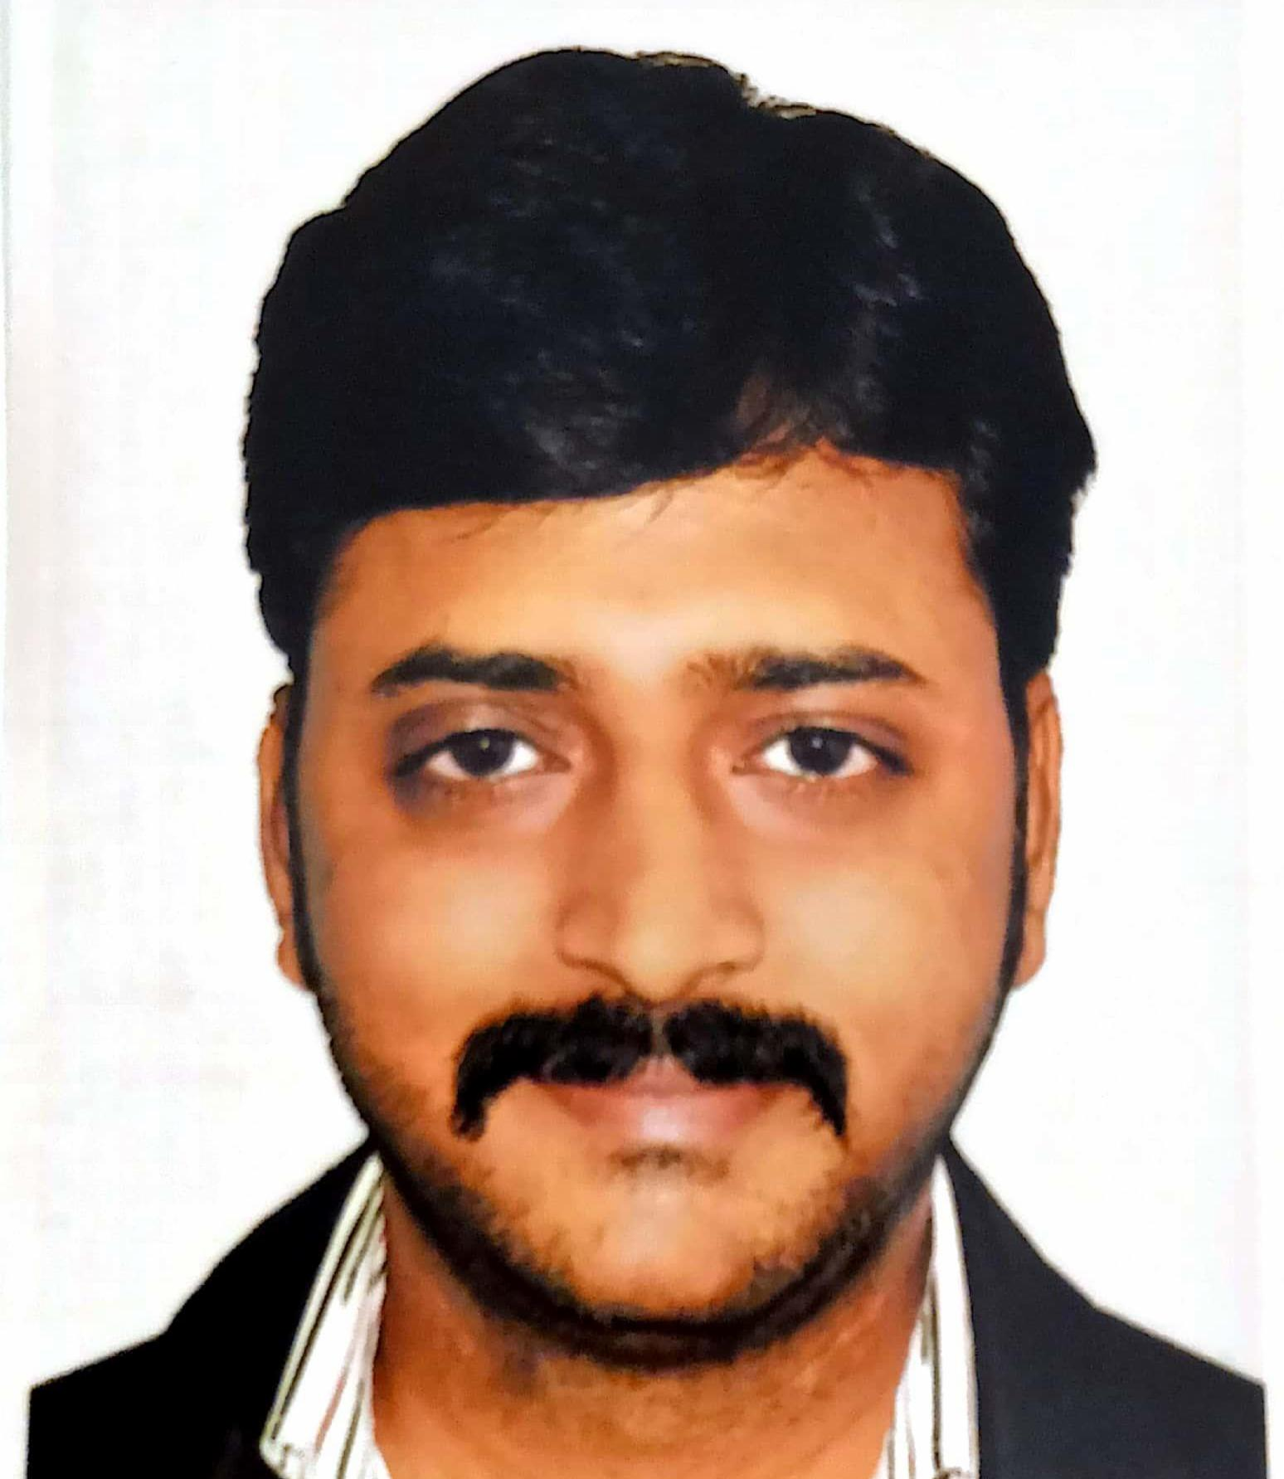 |   Archibaldweg 12, 10317 Berlin (Germany)

(+49)1745454398

sivarama_krishna@live.com

https://www.linkedin.com/in/sivaramakrishna-chennojwala-69b059174/

Skype Sivaramakrishna33
 | Sex Male | Date of birth 28/04/1982 | Nationality Indian

JOB APPLIED FOR | Project Manager

WORK EXPERIENCE

17 Feb 2014–30 Sep 2018 | Project Manager
17 Feb 2014–30 Sep 2018 | T-Systems Malaysia Sdn Bhd, Cyberjaya (Malaysia)
17 Feb 2014–30 Sep 2018 | Responsible for delivering projects against agreed scope, budget, schedule & customer expectations. Doing this whilst supervising, directing & motivating teams of multi-discipline contractors & employees.  Responsibilities:  - Monitoring project risks and scope creep to identify potential problems and proactively identifying solutions to address them in advance.  - Escalating promptly any issues that may impact operations.  - Producing stage plans, highlight reports, risk logs, requests for change etc  - Providing strategic direction during the implementation stages.  - Managing client expectations by ensuring the delivery of the highest quality service  - Acting on client feedback.  - Monitoring staff & team performance.  Project Management skills  - Commercial awareness & business acumen.  - Experience of working in multi-vendor environments.  - Good conflict management and prioritization skills.  - Manage the technical process and resolve technical issues.  - Can understand and document project requirements and dependencies.  - Excellent documentation & report writing skills.  - Experience of managing change within CRM, Marketing and Finance systems.  - Demonstrated ability to work with and support cross-functional project teams.  - Ability to manage multiple projects simultaneously and under pressure.  - Strong attention to detail and focus on task completion.  - Internal and External Stakeholder Management

1 Jul 2013–30 Jan 2014 | Senior Database Administrator
1 Jul 2013–30 Jan 2014 | Sri Soft Solutions Sdn Bhd, Kuala Lumpur (Malaysia)
1 Jul 2013–30 Jan 2014 | Responsible for Design, Installation and Configuration of SQL Server 2008 R2 on Windows Server 2008 Platform. Provided 24*7 Production support for the databases and Application issues.  Responsibilities :  - Experience in upgrading SQL Server from version 2005 to 2008.  - Have good experience with partitioned schemas, partitioned tables and indexes, creating Filegroups using SQL Server 20008.  - Good experience with SQL Server 2008 online Indexing and Recovery features.  - Good experience with implementing DR solution, High Availability of database servers using Database mirroring and replications and Log Shipping.  - Experience in Data Migration Management.  - Experience in implementing SQL Server security and Object permissions like maintaining Database authentication modes, creation of users, configuring permissions and assigning roles to users.  - Created maintenance plans to perform index de-fragmentation, re-indexing and update the index statistics.  - Experience in creating Jobs, Alerts, SQL Mail Agent and scheduling DTS and SSIS Packages.  - Extensive experience in writing Distributed Queries between SQL Servers by creating link servers and federated servers.  - Experience in implementing different types of Replication Models like Snapshot, Merge and Transactional on basis of business specification.  - Experience in performing integrity checks. Methods include configuring the database maintenance plan wizard and DBCC utilities.  - Experience in troubleshooting SQL issues by using SQL Tools, execution plans, Trace, statistics, index tuning wizard.  - Experience in using Performance Monitor, SQL Profiler and optimizing the queries, tracing long running queries and deadlocks.  - Experience in applying patches and service packs to keep the database at current patch level.  - Experience in migrating packages from DTS to SSIS.  - Good experience with Analysis Services, Reporting Services, and SQL Server Clustering.

1 Feb 2012–30 Jun 2013 | Senior Database Administrator
1 Feb 2012–30 Jun 2013 | SourceOne Technologies Pvt Ltd, Hyderabad (India)
1 Feb 2012–30 Jun 2013 | Accountable for the design, configuration and installation of all major production, development and test SQL database environments on Windows Server platforms. Major activities include logical and physical database design, capacity planning, performance tuning, database security, disaster recovery, installation and ongoing maintenance with a special emphasis on web based server administration automation. Other activities include evaluating and selecting SQL database tools responsible for database and application tuning, capacity planning and database stability.  Responsibilities :  - Responsible for installation and configuration of SQL server 2012 database on Dell Servers.  - Involved in data modeling for the application and created ER diagram using ERWin.  - Database Objects like Tables, Stored Procedures, Views, Triggers, Rules, Defaults, user defined data types and functions for this project.  - Implemented database standards and naming convention for the database objects.  - Developed DTS packages to extract, transform and load into the Campaign database from OLTP database.  - Involved in loading the partner flat files into the OLTP database. Also, developed the T-SQL stored procedures/functions to process these data and populate them in the appropriate destination tables.  - Created and configured an OLTP replication database for disaster recovery purpose.  - Worked with developers to tune the SQL queries using SQL Profiler.  - Worked with Star Schema, Cubes and Analytical services.  - Database upgrades, patching & configured sector alignment for storage systems using Diskpart  - Designed data Partitioning solutions for tables and indexes & Risk monitoring & control  - Performance Tuning & Establishing integrated change control.  - Proficient using DMVs, Wait-States & Performance Monitor Counters to quickly find the Root Cause of performance slow-downs.  - Built best usage processes of Dynamic Management Views & SSIS Management Framework design to troubleshoot issues & estimating resource activity.  - Security Architecture & Policy Based Management including  - Experience with Authentication, Auditing, File & Data Encryption using Certificates  - Modified Cryptography using Symmetric & Asymmetric (Public & Private) Keys to encrypt /decrypt the Master Key.  - Provided 27 * 7 Production support for the database and application issues.  - Troubleshoot database performance issues and tune database objects. Set up traces and Profiler to troubleshoot performance issues. Analyze deadlocks & diagnose issues on the server. Troubleshoot Infrastructure issues related to SQL database server such as memory, CPU, I/O, Disk, etc. Monitor log files to proactively resolve issues.  - Proven experience in maintenance of SQL Server in a VLDB environment & experience in troubleshooting and resolving database problems.  - Perform day to day Database Maintenance tasks - Clustered & Non-clustered Database Monitoring, Backups, Space Management, Resource Utilization, responsible for performing object migration between all production database Servers.

7 Jul 2007–30 Jan 2012 | SQL Database Administrator
7 Jul 2007–30 Jan 2012 | Dell International Services Pvt Ltd, Hyderabad (India)
7 Jul 2007–30 Jan 2012 | Responsibilities :  - Involved in installation and configuration of SQL server 2000 on Dell Servers. Applied patches and service packs to keep the database at current patch level.  - Created Database Objects like Tables, Stored Procedures, Views, Triggers, Rules, Defaults, user defined data types and functions.  - Suggested Disk Capacity, Processors and Memory based on the Capacity planning.  - Implemented database standards and naming convention for the database objects.  - Conversion the legacy systems data into MS SQL server using DTS packages.  - Developing SQL scripts for maintaining administration tasks.  - Tuned the SQL queries using SQL profiler. Involved in tuning the database.  - Upgrade the MS SQL server from 2000 to 2005, 2005 to 2008.  - Updating with latest service packs and security patches.  - Based on the business need created all three replication models on different applications.  - Implementing standby servers and Log shipping.  - Involved in developing stored procedures, triggers for the application.  - Estimating of Table sizes and Record sizes. Maintaining proper licenses.  - Maintain all the SQL documents includes installation and data conversion Procedure documents.  - Trouble shooting Problems by using SQL server profiler.  - Solved critical production problems and performed point in time recovery plans.

17 Oct 2005–15 Jan 2007 | Software Test Engineer
17 Oct 2005–15 Jan 2007 | Infosys Technologies Pvt Ltd, Hyderabad (India)
17 Oct 2005–15 Jan 2007 | Create and maintain test plans, strategies, metrics, defects, and summary reports. Develop close relationships with developers to ensure software business requirements are achieved. Assist in creating process documentation.  Responsibilities :  - Experienced in designing and executing Test cases based on Business requirements and Technical Specifications document.  - Excellent knowledge on preparing Test Scenarios, Test Cases for module/integration/system testing, Defect Reporting.  - Performance monitors setup and maintenance on Site scope and BAC  - Understanding of the Requirements and work flow for Applications.  - Worked on different protocols including Web HTTP/HTML, Web Click and Script.  - Testing and mapping Applications on the “custom dashboard” made for the clients to monitor the real time data.  - Setting Thresholds and maintaining the scripts.  - Troubleshooting generated scripts.  - Creating Availability/Performance Analysis Reports.  - Worked on few QTP scripts (Recording web and window based Applications and debugging errors in script)

EDUCATION AND TRAINING

5 Jul 2013–10 May 2015 | Master of Business Administration | EQF level 7
5 Jul 2013–10 May 2015 | Infrastructure University Kuala Lumpur, Kuala Lumpur (Malaysia)
5 Jul 2013–10 May 2015 | Business Administration/Management

PERSONAL SKILLS

Mother tongue(s) | Telugu
Foreign language(s) | UNDERSTANDING |  | SPEAKING |  | WRITING
Foreign language(s) | Listening | Reading | Spoken interaction | Spoken production
English | C2 | C2 | C2 | C2 | C2
German | A1 | A1 | A1 | A1 | A1
Levels: A1 and A2: Basic user - B1 and B2: Independent user - C1 and C2: Proficient user
Common European Framework of Reference for Languages

Communication skills | - Excellent Communication skills gained through various positions in my previous companies.

Organisational / managerial skills | My experience of working with various projects, streams and managers has allowed me to develop productive team strategies to meet differing requirements. In these opportunities, I demonstrated the ability to control, manage and address complex projects and teams of varied cultures.  I lead by example and approach all my work with energy and enthusiasm. My core capabilities of positive attitude, compassion levels, adaptability and agility towards change, being organized are my assets. I believe it is my interpersonal skills that have driven my success in fostering strong workplace processes and relationships with people from multiple cultures.  - Prince2 Certified

Job-related skills | - Worked with Software engineers, Product Managers, QA engineers in an Agile team environment.  - Actively engaged in the creation of new disruptive and transformation products and services.  - Lead squads (scrum teams) dedicated in the implementation of Proof-of-Concepts (POCs), Prototypes and Pilots with strategic customers.  - Supported the Technology Development Managers / Directors to prioritize concept requests at each stage of the OIC process (e.g. ideation, concept validation, agile prototyping).  - Participated in the building and enhancement of a robust pipeline to support the automation of various development associated tasks to achieve continuous integration and delivery.  - Achieved higher rate, quality and lower cost of prototyping, experimentation, and concept pilots by leveraging Design Thinking, Agile methodologies, best practices and reuse.

Digital skills | SELF-ASSESSMENT
Digital skills | Information processing | Communication | Content creation | Safety | Problem solving
 | Proficient user | Proficient user | Proficient user | Proficient user | Proficient user
 | Digital skills - Self-assessment grid

