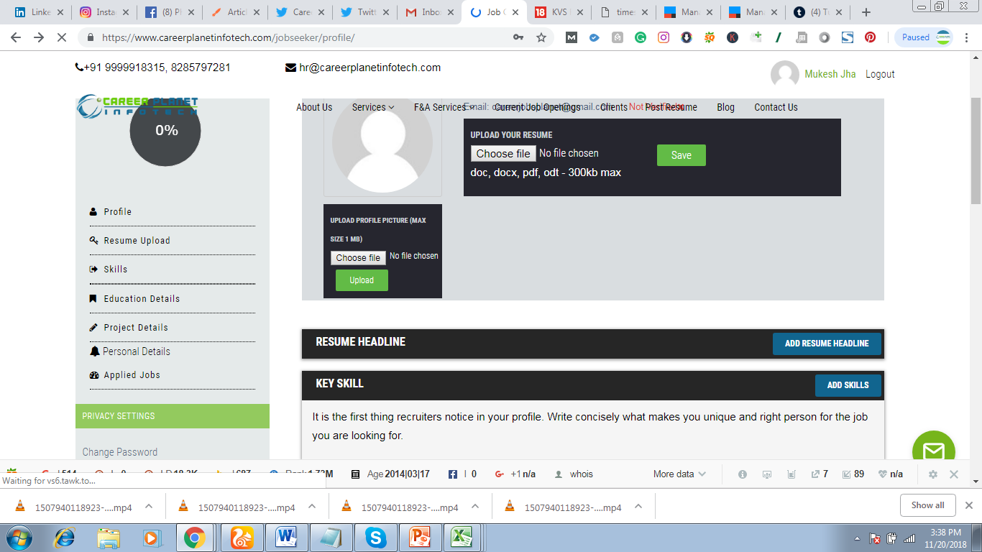

Even the fonts are different and in last two block in left side there is no gap line b/w Personal Details and applied Jobs