Your online branding partner who would help you in your admission assistance with our traffic and receptive registered candidates that we engage with. A Placement Facilitator for all placement challenges for your candidates through Premium Association. Engage with the audience and educate them on your training programs. Also access to registered database through the online packages. We have end to end solution for all your challenges..

Career Planet Infotech offers to partner with your esteemed institute to improve the placement activities and better visibility for your college among recruiters through online and on ground activities like online/off campus recruitment, students training and placement assistance. We serve over 1000+ recruitments per year and is connected with Indian top colleges, this has equipped us to analyze and speculate on some of the key areas where Career Planet could help the campus in improving the brand visibility and connectivity among the Top Corporate in India.

Career Planet having an experience of over 5+ years in the Fresher campus recruitments in ITES & Non Ites, and with our strong online presence and network among the recruiters will help in the placement of fresh graduates.

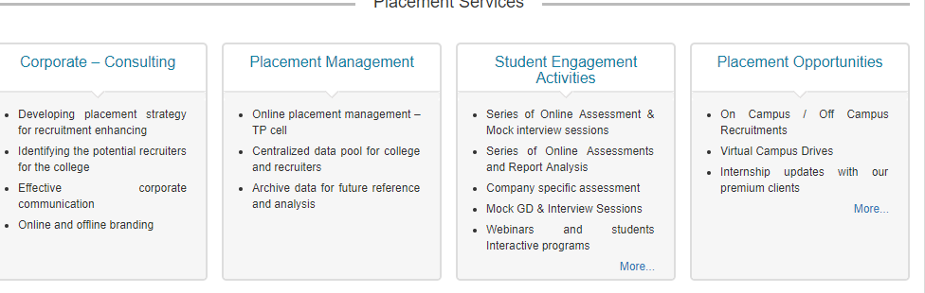

Rakhi.crc@mriu.edu.in 