**RESUME**

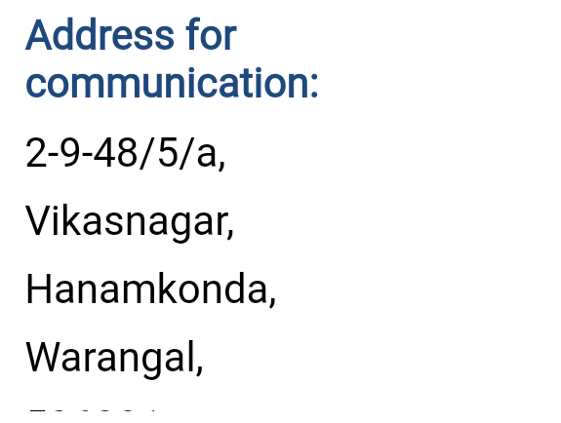

**Name:** Naveen kumar budimalla

**Email:** [navnb574@gmail.com](mailto:navnb574@gmail.com)

**Mobile: +**91-9959831338

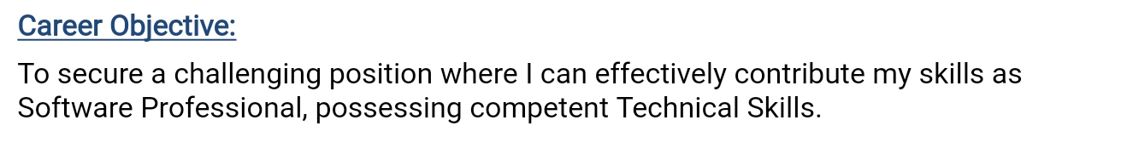

**Educational Qualifications:**

|  |  |  |  |
| --- | --- | --- | --- |
| **LEVEL OF EDUCATION** | **INSTITUTION** | **BOARD/UNIVERSITY** | **YEAR OF PASSING** |
| M.Tech (Branch cse) | Cmr Engineering college | Jawaharlal Nehru Technological University,Hyderabad | 2017 |
| B.Tech (Branch cse) | Jayamukhi Institute of  Technological Sciences | Jawaharlal Nehru Technological University,Hyderabad | 2014 |
| Intermediate  (science+maths stream) | Gmr Junior College | Board of  Intermediate  Education, A.P. | 2010 |
| S.S.C | Zphs mamidyal | Board of Secondary  Education, A.P. | 2008 |

**Computer Skills:**

Programming Languages: C, C++, Core JAVA.

**Experience:**

6 months of experience in Polaris under BPO sector.

1 year Experience in Rainbow childrens hospital F&B cashier

**Project Undertaken:**

**Title:** Call Ranking Log.

**Tool:** Android Development Tool.

**Responsibility:** Desigining the code without any errors and which in turn makes the application to run or execute successfully.

**Description:** **Call Ranking** is an Android based application which is used to find out the number of incoming calls, outgoing calls and missed calls list.

**Achievements:**

* Undergone Two Day Conference on Information Security-InfoSec2013, conducted by Centre for Development of Advanced Computing(C-DAC) in association with School of IT, JNTU Hyderabad and CSI.
* Undergone 50-hours training on mobile application development conducted by IBM software training under the career education program.

**Personal Profile:**

Name : Naveen Kumar Budimalla

Fathers name : B.sathyalingam

D.O.B : 04/07/1991

Nationality : Indian

Languages : Telugu, English,Hindi

Hobbies : Reading books,Playing Cricket

I hereby certify that all the information provided above is true to the best of my Knowledge.

Place: Warangal,

Date:

**B.Naveen Kumar**

(Signature)