RAJU KUMAR
Mob. No.: - +919818237899  Email ID:- rajukmr0595@gmail.com |  | 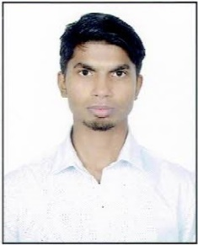
Career
Objective
 | With the knowledge and skills in Mechanical Engineering, I will contribute to the success of the organization and to secure a challenging position where I can effectively contribute my skills as Professional, possessing competent skills.
Industrial Experience
 | Trainee  (July 2017-Aug 2017) |   Bharat Gears Ltd., Faridabad
Professional
Skills
 | Certification Course |   AutoCAD 2D  (Mechanical Drafting)
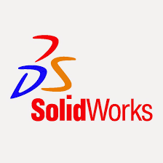
SolidWorks 3D

IT
Skills
 | Language “C” |  | F.C.A
Academic
Credentials
 | Bachelor of Technology  (Mechanical Engineering) | H.N.B.G.U  (Srinagar,Uttarakhand) |  |  |  |  |  |  |  |  | 59.64% |  |  | 2014-2018
 | SSCE(12th)  (C.B.S.E) | G.B.S.S, Kidwai Nagar  (New Delhi) |  |  |  |  |  |  |  |  | 53.2% |  |  | 2012
 | SE(10th)  (H.B.S.E) | Modern Public School  (Faridabad) |  |  |  |  |  |  |  |  | 67.8% |  |  | 2010
Project
 | Academic Project:-
 |  | Organigation:- H.N.B.G.U
 | Project: - Design and Fabrication of Stir Casting Furnace.
 | Description:-
 | After designing of stir casting furnaces, We prepared the Al alloy component
 | with reinforced material (TiB₂) and performed various test for the observation
 | of characteristics change in material after adding reinforcement material.
 | Job Role:- Preparation of testing samples.
Subject of
Interests
- Engineering Drawing
- Machine Design
Achievements
 | Certificate:- |  |  |  |  |  |  | 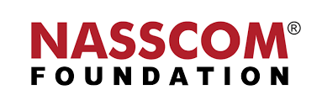  Completed “Life Skills” training conducted by “NASSCOM”
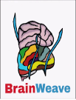
Appreciation from “Brain Weave” for “Campus Ambassador”
Hobbies
 | - Travelling & Exploring new places.
 | - Sports like Cricket
 | - Listening Music
Personal
Profile
 | Date of Birth |  |  |  |  |  |  | 05 May,1995
 | Nationality |  |  |  |  |  |  | Indian
 | Gender |  |  |  |  |  |  | Male
 | Languages known |  |  |  |  |  |  | English & Hindi (Native)
 | Communication Address |  |  |  |  |  |  | H.No:- 25/2, 1A, Block-G
 |  |  |  |  |  |  |  | Molarband Extension, Badarpur Border
 |  |  |  |  |  |  |  | New Delhi:- 110044
Declaration
I hereby declare that the all above information is correct to my knowledge and belief.
Place:- New Delhi |  |  |  |  | Raju Kumar

