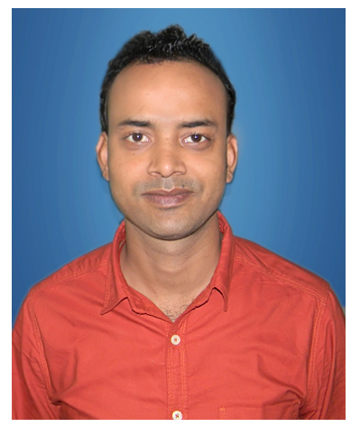

|  |  |  |  |  |
| --- | --- | --- | --- | --- |
| |  | | --- | | **NAME- ANUP KUMAR KESHARI** | | **Date of Birth :20/01/1990** | | |  |
| B.TECH (ELECTRICAL AND ELECTRONICS ENGINEERING)   |  | | --- | | **CONTACT** | | **MOB : 7991185860,7562025862**  **E-mail :** [**kesharianup090@gmail.com**](mailto:kesharianup090@gmail.com)  **Passport Number :** **M6606199** | |
| |  | | --- | | **CAREER OBJECTIVE: -** | | To achieve a challenging position where I can effectively contribute my skills and seeking a position in Electrical Engineering (Maintenance), which offers Professional growth while being resourceful, innovative and flexible. |  |  | | --- | | **PROFESSIONAL EXPERIENCE: -** | | * Having more than 3 years of experience in plant maintenance. * Working in Electrosteel steels ltd.Bokaro Under SRG earth resources ltd. (0.5 MPTA Vertical type Non recovery coke oven Plant) as High skilled technician in Electrical Maintenance from Sept-2013 to April 2017**.** | |
|  |
| |  | | --- | | **JOB PROFILE: -** | | * Cable Laying and Termination for MCC, Motors. * All electrical maintenance (preventive and breakdown). * Maintenance of MCC panel Heavy oven machines like pusher car, charging car, Guide Car, Quenching Cars, Stamping set etc. * Maintenance of 415 V LV panel like PCC, PDB, PMCC, MCC & ACB and LV motor upto 162 KW. * To attend the preventive as well as breakdown maintenance related to electrical controlling and power wiring of plc automated lines, & ac drives. * Maintenance and Troubleshooting of Proximity sensors, Lever limit, ZSS, Thermocouples, RTD, safety switches of conveyors. * Troubleshooting of Real time problems in machines, Conveyors and Feeder during breakdown and finding solution for the problems related to control . * Effective co-ordination with contractors and sub contractors. | |
| **EDUCATION** |
| |  |  |  |  | | --- | --- | --- | --- | | **Degree** | **Board / University** | **Year** | **% marks / CGPA** | | B.TECH. (EEE) | Punjab Technical University | 2012 | 73 | | INTERMEDIATE (+ 2) | B.S.E.B | 2007 | 53 | |
|  |
| |  | | --- | | **RESPONSIBILITIES: -** | | * List down the major maintenance operations and plan for each operation * Planning & scheduling of maintenance activities Electrical, Mechanical epuipment. * Analysis of machinery status & efficiency for inventory control. * Responsible for to achieve production target after commissioning of plant /equipments. * Panel wiring & Field wiring. | |
| |  | | --- | | **PERSONAL STRENGTHS: -** | | * Complete the assigned task at any cost. * Ability to understand the technical need of the work to be done. * Confidence, Discipline, Motivation, and good hold over the job. * Easy adaptability of the various systems. * Self-motivation, Like Challenges, Adaptability, Strong willpower, Ability to work as team with Punctuality & obediently, willingness to learn, Responsible, Result-oriented. I am a sincere, self-motivated individual. * My drive for hard work and the ability to take the initiatives under pressure makes me a suitable candidate for the applied profile. |  |  | | --- | | **SOFTWARE/COMPUTER PROFICIENCY: -** | | * Operating Systems : Windows7, Windows 8, Windows vista, * Software’s : MS Office. * AutoCad : Electrical (2D). | |
| |  | | --- | | **INTERESTS & HOBBIES** | | * Playing cricket and managing events. * Listening Music | |
|  |

|  |
| --- |
| **PERSONAL DETAILS: -** |
| Fathers Name Late- Brahmdeo Narayan keshari  Gender Male  Languages Known Hindi, English, Bhojpuri.  Permanent Address At- Satgharwa,jail road,Arrah,Bihar  Contact no. 7562025862 / 7991185860  Passport no. M6606199 |

|  |
| --- |
| **DECLARATION: -** |
| I hereby declare that the above mentioned information is correct up to my knowledge and I bear the responsibility for the correctness of the above mentioned particulars. |

Date:- Place: -