AHRAZ TYAGI | Looking for a challenging opportunity to kick off my professional career with.
SUMMER TRAINING PROGRAM

* A to Z Automobiles (2017)
Duration: 4 weeks
Title: Workshop on Automobile & Engine Design
Synopsis-
- To understand the basics of automobiles
- Engine overhauling
- Steering geometry
- Denting and painting
- Sensors

* Go-kart Design and Fabrication, ISNEE (2016)
Duration: 6 weeks
Title: Go-Kart Design and Fabrication
Synopsis-
- To understand the basics of go-kart
- Designed various components of go-kart and analyse them on SolidWorks
- Manufacturing of different parts of go-kart and fabricated them all
- Testing phase

EDUCATIONAL CREDENTIALS

B.Tech ( M.E. ) | Uttarakhand Technical University | 70% (aggregate)
12th | Aadarsh Bal Niketan ( C.B.S.E. ) | 68.8%
10th | Aadarsh Bal Niketan ( C.B.S.E. ) | 8.8 (C.G.P.A.)

PROJECTS UNDERTAKEN
- Modelling of connecting rod in SolidWorks
- Go-kart
- Designing of Steering assembly in CATIA
- Designing of F1 race car tyre
CERTIFICATION
- Designing of IC Engine components in SolidWorks software
- Pro-E
- Sketch-o-car
- CATIA
- SolidWorks
- AutoCad
KEY SKILLS
- Hard Working and Team Player
- Strong academic training in Mechanical Engineering
- Well versed with designing work in Solid Works

MECHANICAL ENGINEER
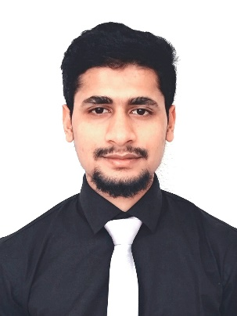
PERSONAL INFO
Phone
+91 81267 13378

Current Location
BANGALORE

Email
Ahraz.tyagi@outlook.com

Year of Birth
1996

Hobbies
Sketching

Preferred location
Anywhere in India

