**DIPTY KUMARI**

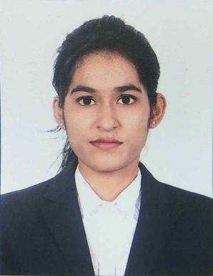

**Address**- Welcome PG, Bhagwan Nagar, Near Bhumkar Chowk, Wakad, Pune-411057

**Mobile**: +91-9082527609/ 7350910481

**E-mail**: diptykumari14@gmail.com

[dipty.kumari@indiraicem.ac.in](mailto:dipty.kumari@indiraicem.ac.in)

**Specialization:** Human Resources

**Education:**

|  |  |  |  |  |
| --- | --- | --- | --- | --- |
| **MBA** | Indira College Of Engineering and Management, Pune | Pune University | 2017-2019 | Appearing |
| **BCA** | M.D.D.M College  Muzaffarpur, Bihar | B.R. Ambedkar  Bihar University | 2012-2015 | 65% |
| **HSC**  **(Science)** | SKM College,  Begusarai, Bihar | Bihar Board | 2010-2012 | 72% |
| **SSC** | Omar Girls High School, Begusarai, Bihar | Bihar Board | 2009-2010 | 72% |

**Project Details:**

**Company: Reliance Jio Infocomm Limited Pune**

**Project Title: Capability Building Of Employees Through Learning & Development.**

**Duration:** 3 Months (15th May 2018 to 15th August 2018)

**Details:**

* Worked Under Training & Development Team.
* Conducted E-learning Training.
* Arranged Induction Program for Newly Joined Employee.

**Achievements:**

* **In the month of May I completed 100% RFR Certification of Employees.**
* **In the month of July I completed 100% Mandatory Certification of Employees.**
* **Provide Training to 50 Employees for completing their Assessment.**
* **Arranged Motivational Training Schedule for Reliance Jio Infocomm Limited Employees.**
* **Awarded as Best Summer Intern for my work.**

**Company: Genesis hr services**

**Duration:** 1 Month (24th Dec 2018 to 24th Jan 2019)

**Details:** Study of hiring Process (Practical knowledge of Naukri Portal, Reference check, Screening)

**Computer Skills:**

**Operating Systems:** Windows

**Packages Known:** MS Office (Word, PowerPoint, Excel)

**Additional Qualification:**

* Attended Certification of **Performance Management System**
* Attended workshop on **Payroll Structuring**
* Successfully completed **Digital Marketing Certification**
* Currently undergoing a 250-hour comprehensive **performance-based Leadership Development Programme** by **Stratecent Consulting** and have acquired the following skills:
* **Negotiation Skills**
* **Problem Solving Skills**
* **Systems Thinking**
* **SPIN Selling**
* **Strategy**

**Extra-Curricular Activities:**

* Coordinator of Paper Presentation at University
* Arranged Blood Donation Camps in Colleges
* Played Badminton for University Team
* Participated in **FASHION SHOW** and **MODELLING** Compitition.

**Personal Details:**

**Date of Birth:** 02/01/1995

**Marital Status:** Unmarried

**Strengths:**

* Problem Solving Approach
* Quick Learner
* Self-Disciplined
* Team Player
* Positive Attitude
* Adaptable & Flexible

**Languages:** English, Hindi