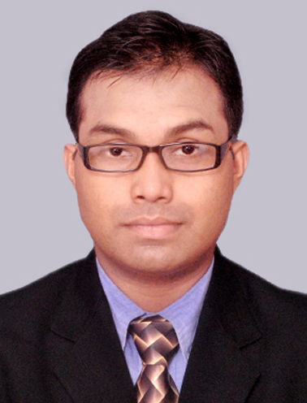***CURRICULUM VITAE***

***PERSONAL DETAILS :***

***NAME*** ***Ashok Halder***

***FATHER’S NAME******Late Arun kumar Halder***

***ADDRESS***  *118/1,R.N.Tegore Road, Purbachal, P.O-Thakurpukur. Kolkata- 700063.*

***MOBILE NUMBER*** *6290569566*

***E-MAIL ID******ashokhalder1983@gmail.com***

***DATE OF BIRTH*** *18th June 1983*

***NATIONALITY*** *Indian*

***RELIGION*** *Hindu*

***HEIGHT***  *5.3 ft (165.5cm)*

***WEIGHT*** *62kg*

***SEX***  *Male*

***CASTE***  *General*

***MARITAL STATUS*** *Single*

***PASSPORT NO******L8471450 (Valid till 31/03/2024)***

***CAREER OBJECTIVE :*** *To perform per expectation & ensure work to be completed & delivered , have the ability & will to work & the power to line up for expectation.*

***SKILL SET :*** *Good interpersonal skills & posses the quality knowledge of culinary & have the ability to create the brand new healthy & delicious recipes & coffees as & when desired or required.*

***LANGUAGES KNOWN :*** *English, Hindi & Bengali.*

***OTHER INTEREST :*** *Music, Cooking, Painting & any kind of creative works.*

***ACCADEMIC QUALIFICATION :***

* *Completed class* ***10*** *under* ***W.B.B.S.E.*** *from* ***BEHALA KISHOR BHAROTI HIGH SCHOOL, KOLKATA*** *in the year* ***1999****.*
* *Completed class* ***10+2*** *under* ***W.B.B.H.S.E.*** *from* ***BEHALA HIGH SCHOOL, KOLKATA*** *in the year* ***2001.***

***PROFESSIONAL COURSES :***

* *Completed* ***2yrs. Advance Certificate*** *in* ***Food Production & Patisserie*** *from* ***THE CULINARY INSTITUTE, KOLKATA*** *in* ***November 2004.***
* *Completed* ***Diploma*** *in* ***Food Production & Patisserie*** *from* ***THE CULINARY INSTITUTE, KOLKATA*** *in* ***November 2005 (****Specialization in* ***Indian & Continental Cuisine).***
* *Completed* ***Brew Master Certification*** *from* ***CAFE COFFEE DAY (Amalgamated Bean Coffee Trading Co. Ltd.)*** *in the year* ***2008.***

***PROFFESSIONAL EXPOSURE:***

* *Worked in* ***HOTEL PEERLESS INN, KOLKATA (Sarovar Park Plaza Group)*** *from* ***November 2004*** *to* ***June 2006*** *in the* ***F&B PRODUCTION DEPARTMENT.***
* *Worked in* ***CAFE COFFEE DAY, KOLKATA (Coffee Day Global Limited)*** *from* ***July******2006*** *to* ***August 2010*** *as* ***CAFÉ IN-CHARGE & BREW MASTER.***
* *Worked in* ***IMPULSE MANAGEMENT GROUP*** *from* ***February 2012*** *to* ***September 2013*** *as* ***ASST. TRAINING MANAGER.***
* *Worked in* ***IT SECTOR (International Process)*** *from* ***2nd October 2013*** *to* ***28th December 2015.***
* *Worked in* ***HOTEL HINDUSTHAN INTERNATIONAL, KOLKATA*** *from* ***8th March 2016*** *to* ***8th November 2017*** *as* ***JR. EXECUTIVE (1st COMMIE)*** *in the* ***F&B PRODUCTION DEPARTMENT.***
* *Worked in* ***ALTAIR BOUTIQUE HOTEL, KOLKATA (AMBUJA NEOTIA HOSPITALITY)*** *from 9****th November 2017 28th April 2018*** *as* ***1st COMMIE*** *in the* ***F&B PRODUCTION DEPARTMENT.***
* *Presently associated with* ***THE JOURNEY KING, KOLKATA ( TJK LIFESTYLE SERVICES INDIA LLP )*** *from* ***03rd August 2018*** *as* ***Business Associate******.***

***DATE : 30/03/2018 …………………………..***

***PLACE : Kolkata (Ashok Halder)***