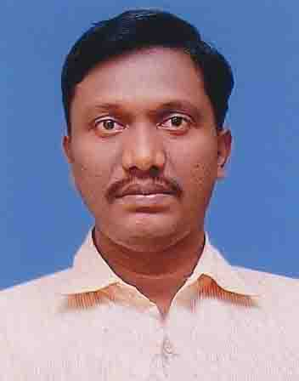
DINESH G
2/282, PANTHAPALLY HOUSE, NAZRETH ROAD,
ALUVA, KERALA, PIN 683101,
Phone: 9895401800.
dineshg800@gmail.com

PERSONAL PROFILES

Father Name Gopalakrishnan C (Goldsmith)
Mother Name Saraswathi Gopalakrishnan (HW)
Nationality Indian
Gender Male
Religion Hindu, Tamil Viswakarma (Goldsmith)
Age, Date of Birth 42, 30/04/1976
Marital Status Single
EDUCATIONAL

Degree Bachelor of Commerce, MG UNIVERSITY - year 1999.
TECHNICAL KNOWLEDGE

Computer PGDCA - Post Graduate Diploma in Computer Application from Indira Gandhi Foundation, Trivandrum - year 2000.
SKILD KNOWLEDGE

Goldsmith Traditional Goldsmith - Gold ornaments designing, making and purity from year 1990.
EXPERIENCE
- Poultry Farming Cunsultent :- Associated with Flywell Poultry Accessories , Trichur from 01/06/2016 on words
- GEO VPL Finance Pvt. Ltd. (NBFC since 1994), 13.7 years experience from 19/11/2002 to 31/05/2016 – Gold loan Department as a Gold Appraiser, Gold Auditor, Branch in Charge, Branch Manager, Regional Manager and Assistant General Manager – Administration Department (Administration / Branch operations).
- Computer Technology Center, Ernakulam: - 4 month Temporary Computer Instructor.
- Traditional Goldsmith – 27 Years experience in Gold ornaments- Designing, Making and purity from 1990.

DECLARATION

I hereby declare that all the above mentioned information are true and correct to my best knowledge and can be supported with relevant documents.

Aluva Thanking You
28/01/2019 Yours faithfully

DINESH G

