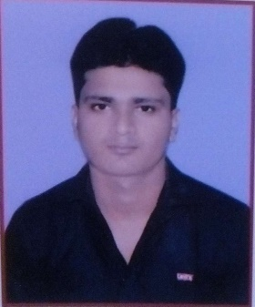

SAURABH KUMAR

E-mail- saurabhdivine1@gmail.com

Address- H. NO. 880/2, Near Mamta Hospital, sec - 12
Gurgaon, (Haryana) 122001

Phone No. - +919896709963,7992215435

___________________________________________________________________________
OBJECTIVE

Seeking a challenging position in your esteemed organization where my technical liaison and co-ordination skills can be effectively utilized to improve operations and contribute to the company’s growth.
Personal Skills:

- Good verbal and written communication skills
- Ability to work hard
- Ability to build motivation
- Creative & self-confident
- Positive approach thinking

Educational Qualification:

- B.Tech in Mechanical Engineering (with 67.5 percentage) from B M College of Tech. & Management, Gurgaon Affiliated to M.D.U. Rohtak.
- Completed Intermediate in the year 2013 from Bihar Board .
- Passed Class 10th from JPNS in the year 2011 from Bihar Board.

SOFT SKILLS:

- Basic in computers
- Operating systems
- Basic in Microsoft excel
- Typing speed 15 wpm

Training:

INTERNSHIP TRAINING:

- Tata Motors Pvt Ltd.
- Duration Time 45 Days

INDUSTRIAL VISIT:
- Automec Pvt Ltd.(Delhi)

Experience:

- Company : Towell Engineering International LLP , PUNE
Duration : 01 july 2017 to 20 December 2018
Position : Mechanical Engineer
- Handle the project of JSSL & JSW as a production Engineer.
- A complete fabrication of I-Section , U-Beam, splice plate, crane garder Bracing.

- Company : SHIVANSH AUTOMATION
Duration : 23rd December 2018 to 10 January 2019 ( for shutdown project)
Description : Conveyor & rail installation engineer
Position : Mechanical Engineer
- CPC Rail Installation in Maruti Suzuki India Ltd, Manesar.
- Aware of Mechanical Drawing

Personal Details:

Father’s Name : Pankaj isar
Mother’s Name : Bibha devi
Date of birth : 28th Nov 1995
Sex : Male
Marital Status : Single
Nationality : Indian
Hobbies : Listening Music, Playing Games.

DECLARATION :

The above mentioned information is true and correct to the best of my knowledge and belief. If I am selected and given a chance to serve in your esteemed organization I shall prove my best and ability to the entire satisfaction of my superiors.

Place: yours faithfully
Date: (SAURABH KUMAR)

