**HARI OM PRAKASH** 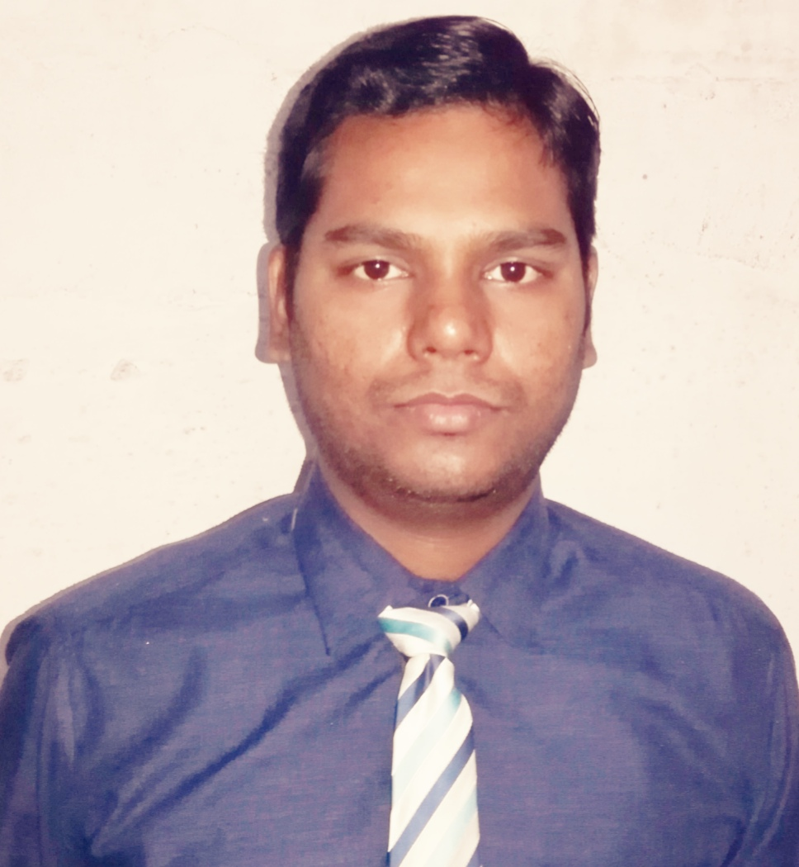

**Mobile:** 8871714996, 8839515367

**Email:** hprakash26@gmail.com

**CAREER OBJECTIVE**

To pursue a highly rewarding career, seeking for job in challenging and healthy work environment demanding all my skills and effort to explore and adapt myself in different fields and realize my potential where I get the opportunity for continuous learning. To serve the nation in technical advancement.

**WORK EXPERIENCE**

2014-2018: Worked in M/s Bansal Infraprojects Pvt. Ltd. A Civil Construction & Infrastructure Development private limited company, Raipur C.G.

* **Jobs & Responsibilities**:
* Served as a Project head in construction of a G+4, office Cum residential building spread over an area of 2400sqft.
* Managed work completed by 8-9 subcontractors including plumbing, electrical, septic, foundation, and flooring.
* Supervised day to day construction activities like formwork, block work, concrete placement and design and also ensuring activities were completed on time
* Completed project management, reporting, and administrative duties. Developed and maintained records of all construction materials and equipments.
* All material purchase and deputing to site.
* Tender checking and selection (internet surfing oriented)
* Online and offline tender submission
* Misc. machinery and spares purchase
* Documentation and record keeping
* Related banking affairs (part)

**EDUCATION**

B-TECH, Biju Patnaik University Of Technology (Bput), Odisha

Gandhi Institute Of Advance Computer And Research, Rayagada

Overall 75% (Mechanical Engineering)

**UNDER GRADUATION**: C.B.S.E Affiliated

INTERMEDIATE: 71.5%, from Lakshmipat Singhania Public School, Jaykaypur

MATRICULATION: 88% from Lakshmipat Singhania Public School, Jaykaypur

**INDUSTRIAL TRAINING**

* J.K. PAPER MILLS LTD., Jaykaypur, Odisha from 29th March to 30th April, 2013.

**PROJECTS**

FINAL YEAR PROJECT: Thermal Power Generation in Power Plant.

MINOR PROJECT REPORT: Study of different types of gears.

RESEARCH PAPER: Solar Power Generation.

**AWARDS AND ACHIVEMENTS**

* **Certificate of Scouting:** Rajya Puraskar Award, Orissa
* **Certificate of Merit on Painting**: From Bharatiya Art Education Society, Mumbai (at school level)
* **Certificate of** **Senior First Aid Trainer:** From St. John Ambulance , Orissa
* **Certificate of Math Olympiad in 1st Division with 61% marks**
* **Merit Cum Means Scholarship:** From J. K .Paper Mills, Rayagada, Orissa
* **Silver Medal:**  in general knowledge at school level
* **Active role in various sports and quiz competitions at school level**

**COMPUTER EFFICIENCY**

OPERATING SYSTEM: Windows 7, 8 , 10

SOFTWARE: Microsoft word, Excel, Power point

COURSE: Autocad (Beginner stage)

MISC: Internet oriented task, surfing

**HOBBIES AND INTEREST**

* Turn best out of waste
* Watching wrestling
* Sketching and painting
* Reading, internet surfing, playing cricket, movies

**PERSONAL DETAILS**

DATE OF BIRTH: 27TH JUNE 1991

GENDER: Male

MATRITAL STATUS: Single

LANGUAGE KNOWN: English, hindi, Odiya

**DECLARATION:**

I hereby solemnly and sincerely affirm that the particulars furnished above are true and correct.

PLACE: Raipur

DATE: