**Araag Batra**

102, Indira Nagar Colony

Dehradun, India

Mobile : +91- 9634999669

Email : araagbatra@gmail.com

Date of Birth : 8th February 1996

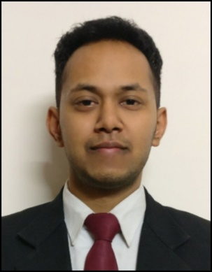

**Objective**

Seeking a platform for gaining practical experience by implementing my theoretical knowledge in the field of Civil Engineering.

|  |  |  |  |  |  |
| --- | --- | --- | --- | --- | --- |
| **Qualification** | **School/College** | **University/Board** | **Year of passing** | **Stream / Degree, Specialization** | **CGPA/ Percentage** |
| Graduate | FST | The ICFAI University, Dehradun | 2018 | B. Tech in Civil Engineering (Gold Medalist) | 9.4/10 |
| 12th | St. Thomas' College, Dehradun | ISC | 2014 |  | 64.2% |
| 10th | St. Thomas' College, Dehradun | ICSE | 2012 |  | 79% |

**Education**

**Internship**

01/2018 – 06/2018 **Construction of 2-Lane road tunnel**

Dehradun, Uttarakhand M/s Bharat Construction

* Inspected steel reinforcement for raft footing as per drawing.
* Co-ordinated and supervised technical aspects of construction project.
* Provided technical advice and supervised staff on site.
* Inspected technical designs and drawings to ensure that they are followed correctly.

06/2016 – 07/2016 **Construction of Flyover and Rail under Bridge**

Dehradun, Uttarakhand M/s C & C Constructions Limited

* Assisted senior engineers in the inspection of all material to ensure engineer's specification and qualities are met.
* Monitored the proper compaction of subgrade layer for flyover ramp and proper placement of geogrid for its reinforcement.
* Inspected steel reinforcement and expansion joints as per drawing.
* Supervised workers for levelling (for the construction of PCC slab) using Auto-level machine.

**Study Project**

08/2017 – 02/2018 **Strength Improvement on Nano-Composite Soil**

Dehradun, Uttarakhand Department of Civil Engineering, The ICFAI University, Dehradun

* Determined the plastic limit and liquid limit of the bentonite soil using glass plate and Casagrande’s apparatus.
* Determined the optimum moisture content and maximum dry density of soil.
* Determined the shear strength of soil by Tri-Axial Shear Test.

**Additional Skills**

Software: AutoCAD (Intermediate), STAAD PRO (Beginner), Cadian (Intermediate), MS-Excel (Intermediate), MS-Word (Intermediate), MS-Power Point (Intermediate)

Languages: English (Fluent), Hindi (Mother Tongue)

**Achievements**

* Awarded Gold Medal in B. Tech in Civil Engineering from the Honourable Vice President of India, Shri Venkaiah Naidu for gaining 1st rank in academics. (Batch: 2014-18)
* National level Air Pistol Shooter.
* Volunteered as Coach in 1st ONGC Ward Shooting Camp in 2015.
* Active volunteer of "Dehradun Animal Lovers" Group for welfare of animals.
* Interests: Swimming, Badminton, Football etc.

Dehradun, 29th March 2019

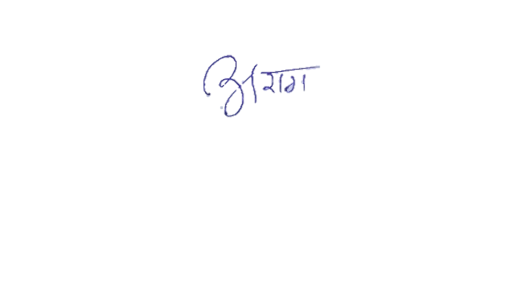

Araag Batra